**Captain Gigi Great Escape**

Design document

Created for

By

TEAM_GG

High concept:

This is a procedurally generated 2d pirate endless runner with platforming and RPG elements.

**Blurb:**

A procedurally generated side-scrolling 2D endless runner. Collect coins and diamonds as you flee from the vengeful ghost of Dervy Jernz and his ghastly curse, avoiding his mutated crew and the cannons set up along the way. Collect temporary power-ups for your run: Double Jump, Ground Dash, and Air Dash to access higher areas, avoid enemies, and better escape Dervy.Just remember... There is no escape from the Curze of Dervy Jernz

**Gameplay:**

* The player, Captain Gigi can run, jump, attack and throw swords.
* The enemies attack Captain Gigi when he’s too close but can be stomped on.
* The traps shoot at Gigi and cannot be stopped.
* The coins and diamonds can buy items in the shop.
* When Gigi loses all his hp or falls off the game level it’s game over.
* The potions grant Gigi special abilities like double jump and dash.

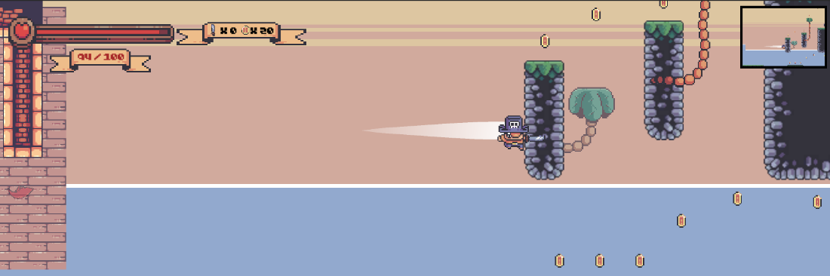

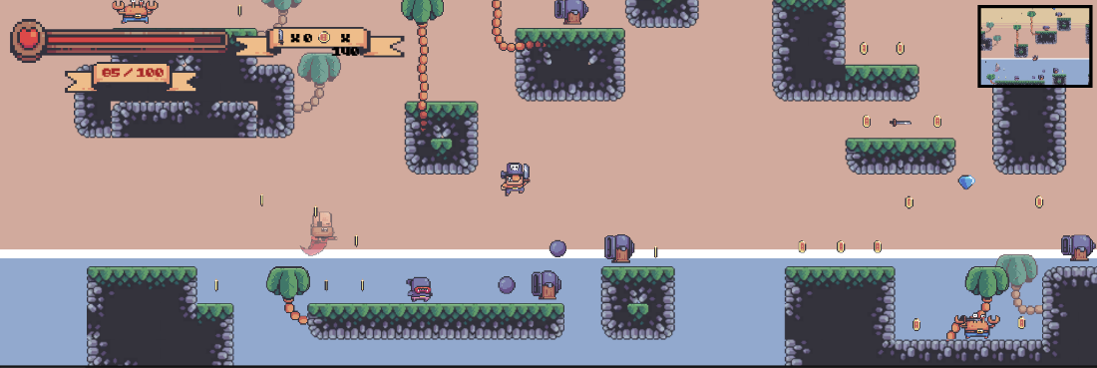

Features:

* Shop to buy temporary items for the run
* Various items for movement options and replay ability
* The speed and difficulties are increased over time
* Avoid the persistent ghost pirate chasing you, when in contact the pirate ghost deals lots of damage
* 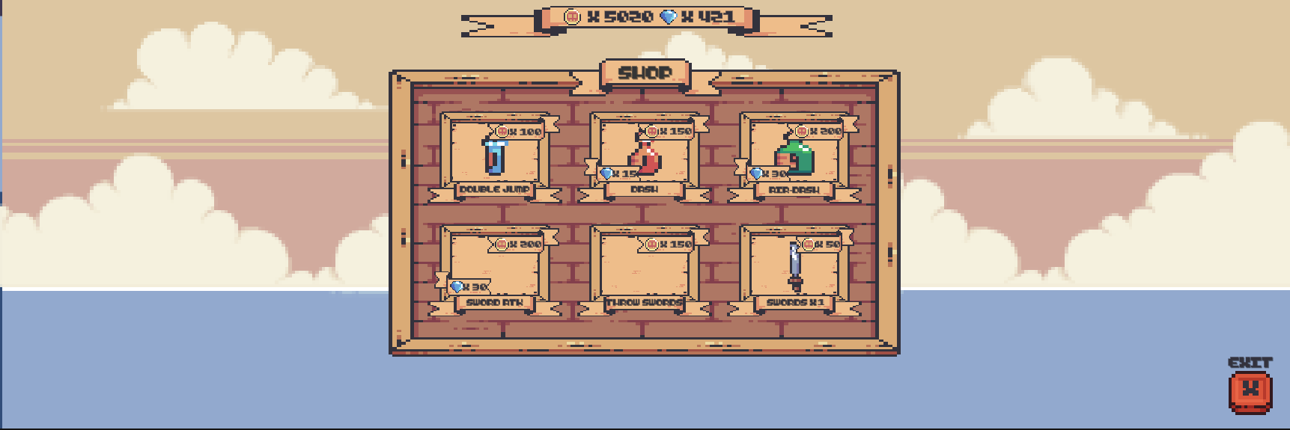

Sourcing:

* Sprites: Treasure hunters, Kings and Pigs, Pirate Bomb asset packs created by PixelFrog <https://pixelfrog-assets.itch.io/>
* Music: Not Jam music pack by Not Jam <https://not-jam.itch.io/not-jam-music-pack>

Sound effects: Minifantasy - Dungeon Audio Pack